**Client’s Manual**  
Project Name: Nampi Bikes  
Dashboard type: WIX

**Dashboard/Home**  
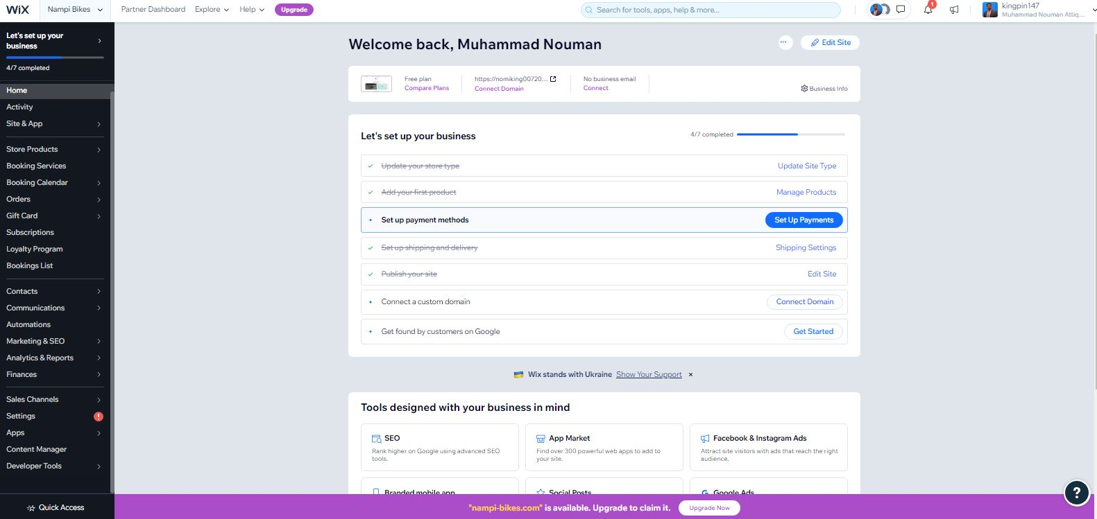  
main page of dashboard.

**Activity Tab:**

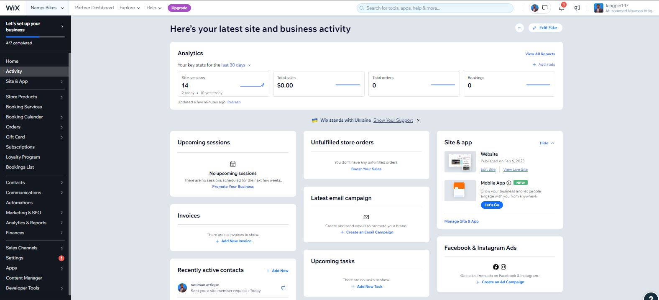

In this page you can see all your website activity in one page.

**Store/Products:**

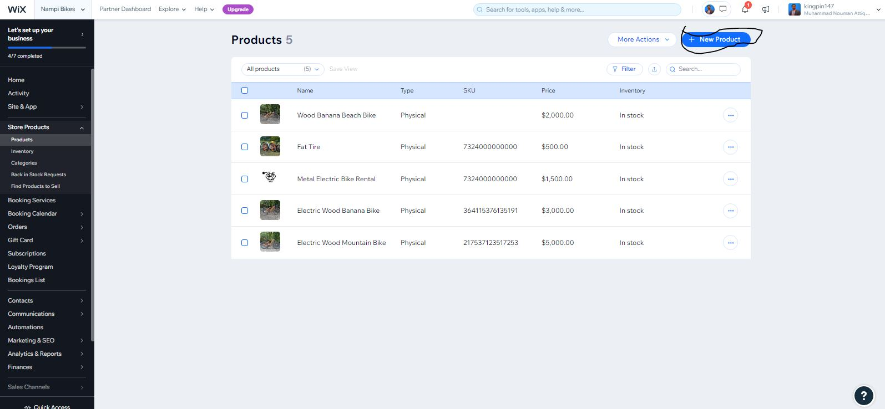

Here your can add your products.

**Store/Inventory**

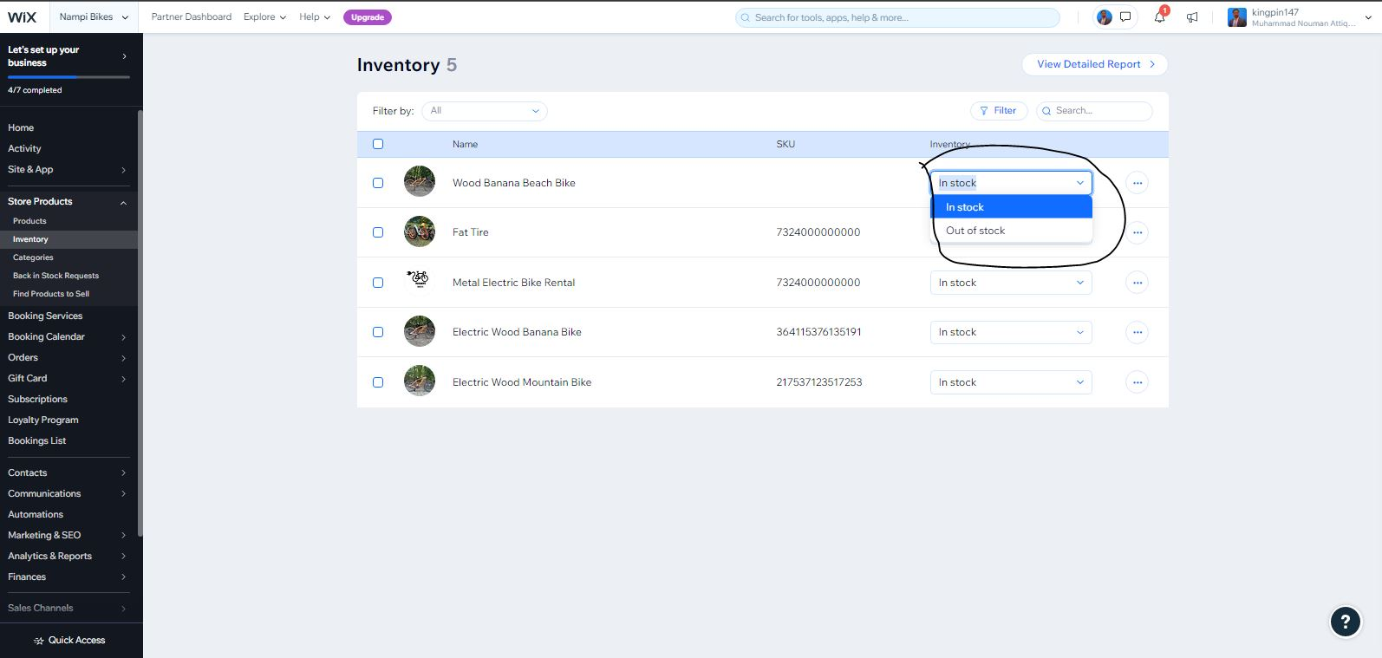here you can manage your inventory of products (in stock/ out of stock)

**Booking/Services**

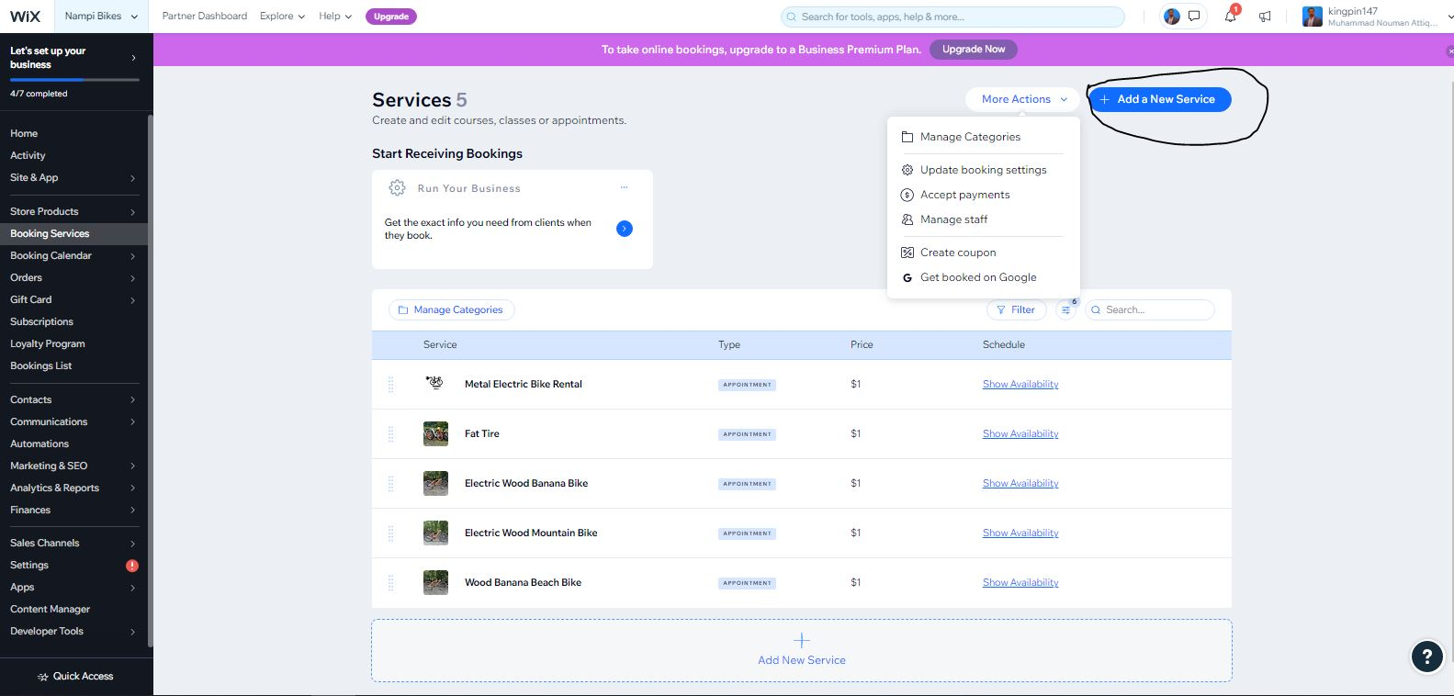

Here you can add your rental products/services or manages them.

**Booking/Calendar**

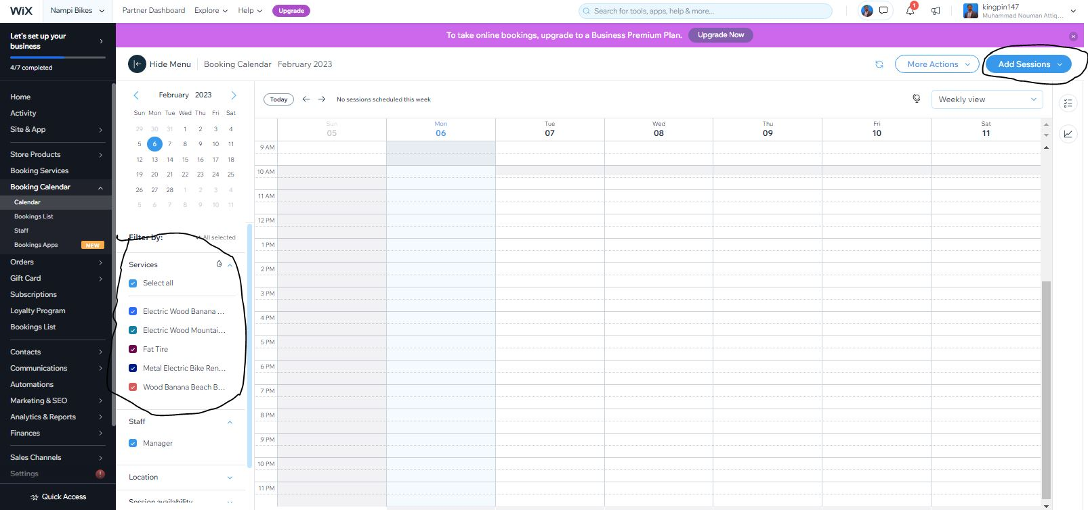

Here you can manage your client’s rental bookings.

**Order/Cart**

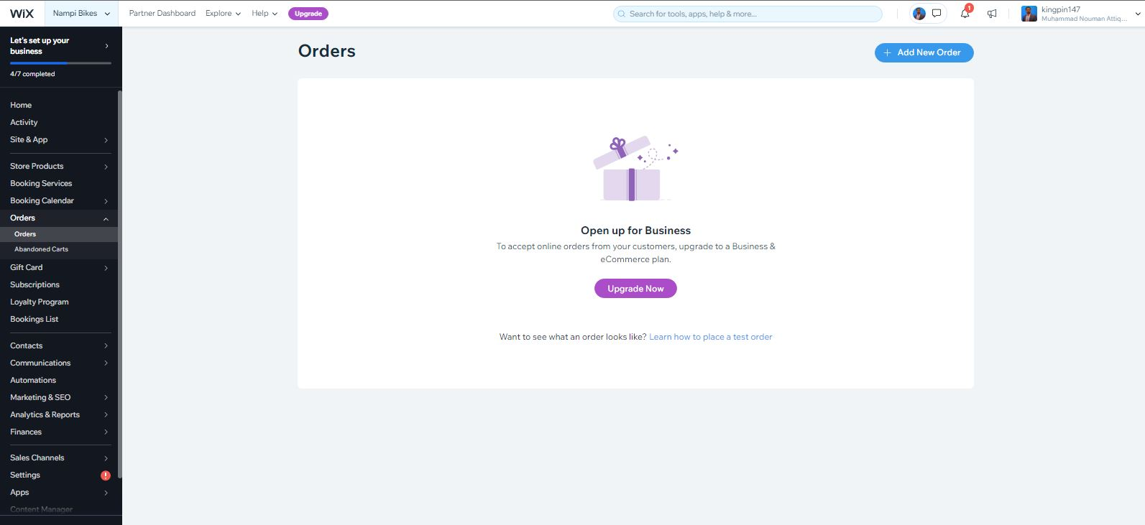

Here you can track orders activity.

**Marketing/SEO**

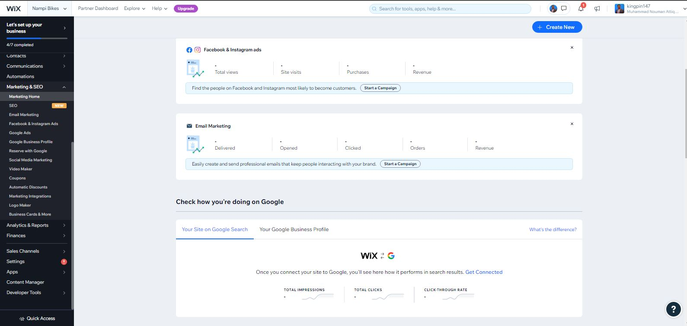

Here you can manage you marketing tools and website SEO.

**Analytics/All reports**

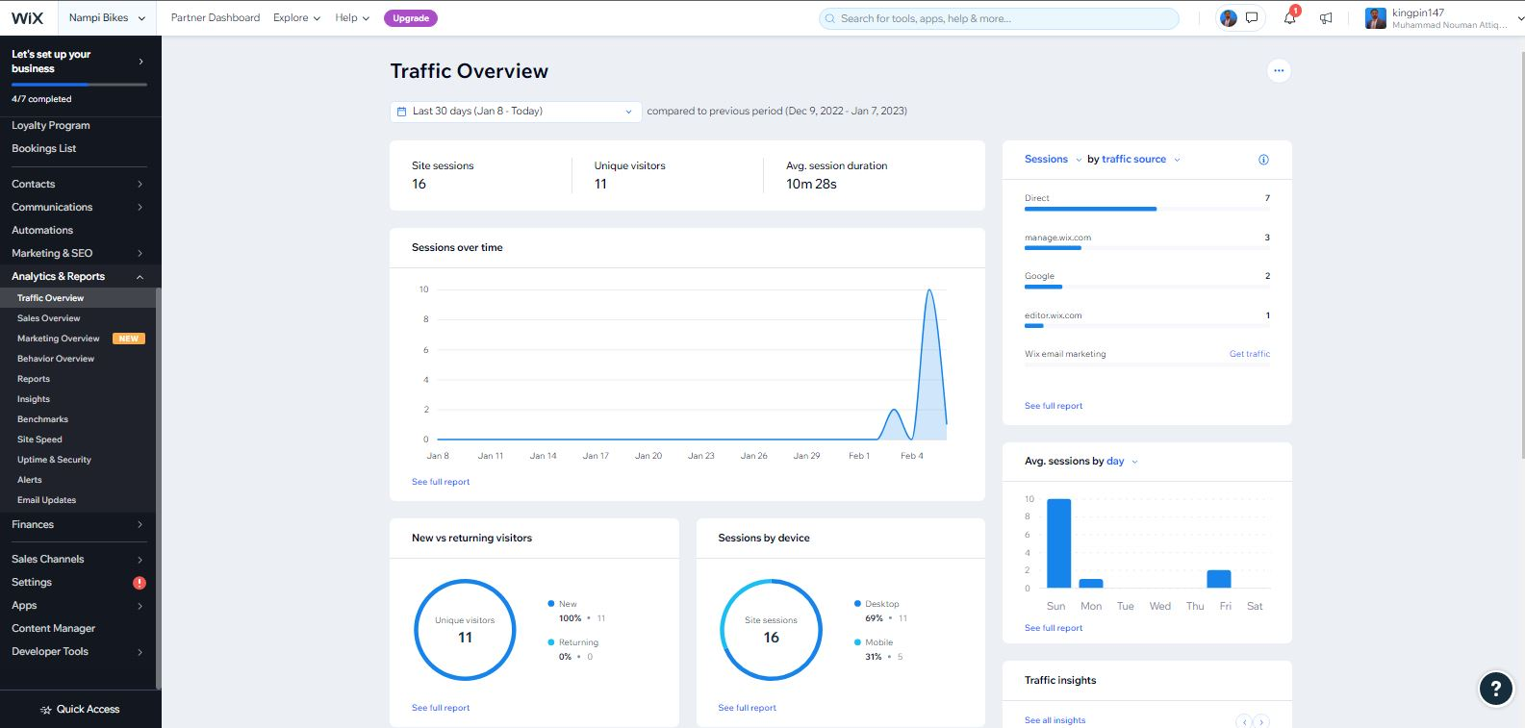

Here you can track performance of website traffic, customers and generate all kind reports for your business improvements.

**Settings/All**

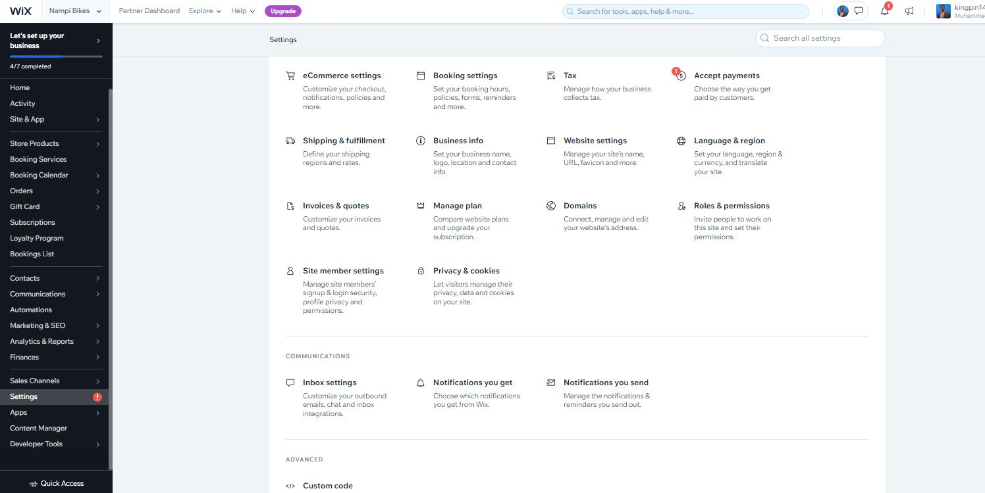

In setting section you can manage your website and dashboard settings.

**Roles/Managers**

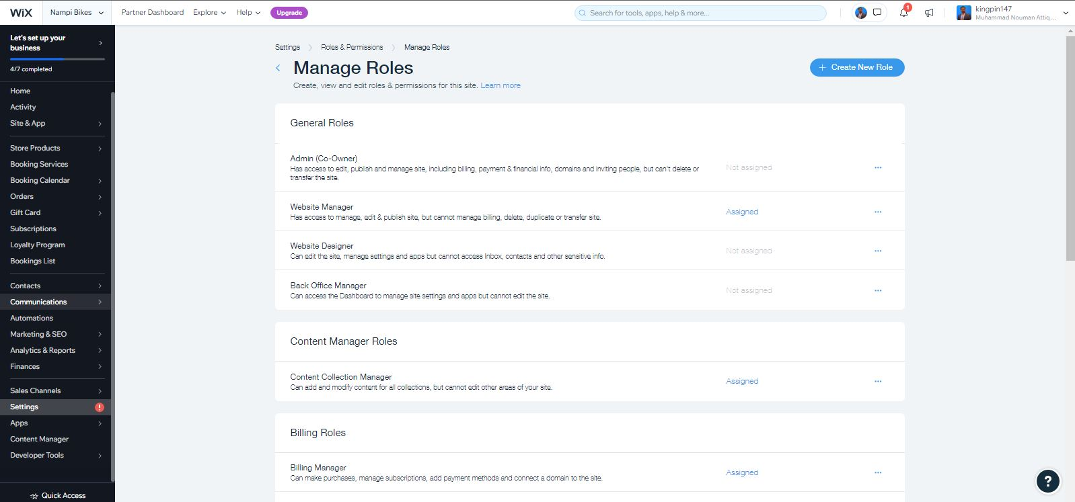

Here you can assign different roles to staff members to manage your website functionalities.

**Site Members**

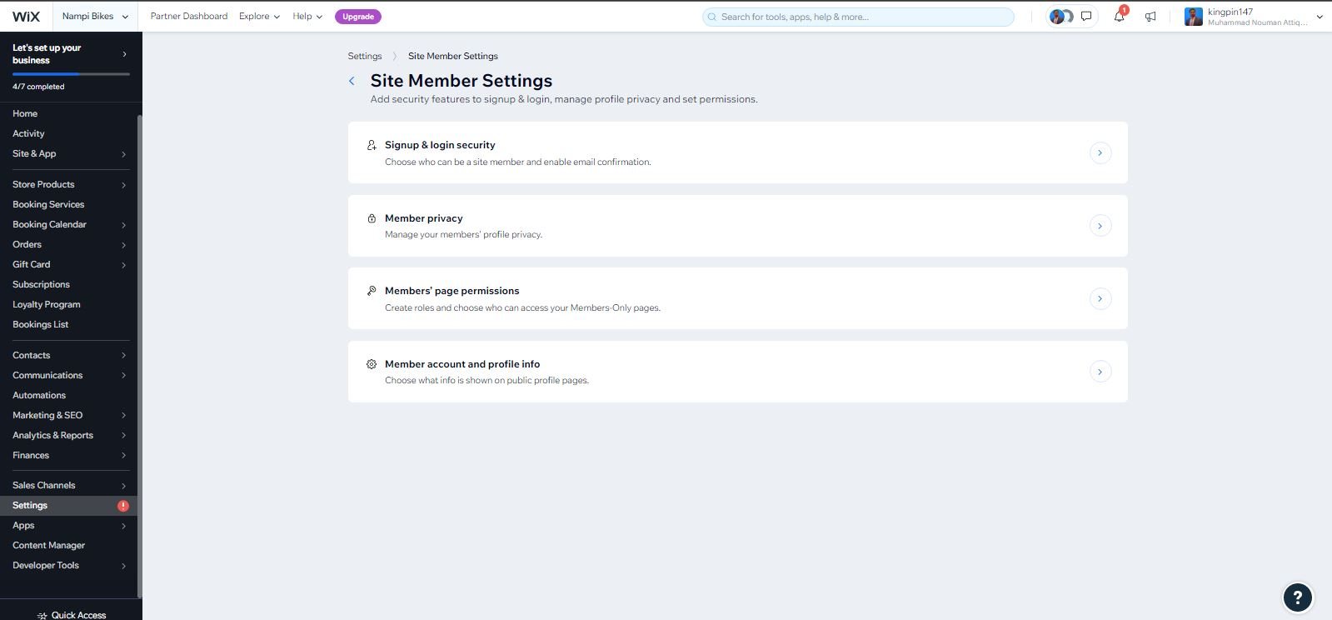

Here you can manages who can signup to your website or who you want add or who you want to delete and view their account activity.